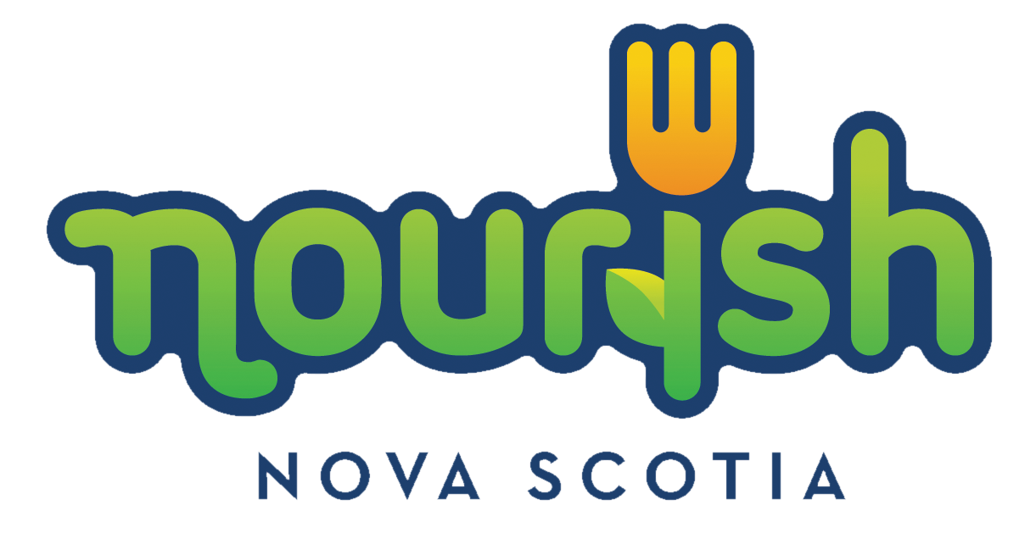

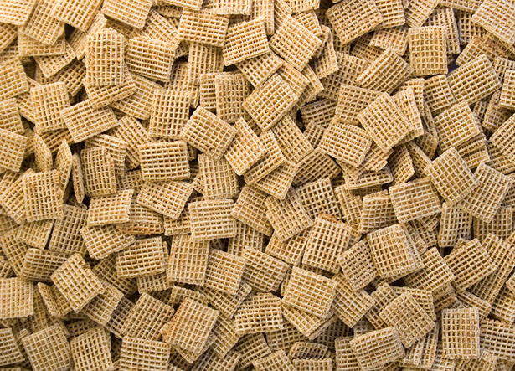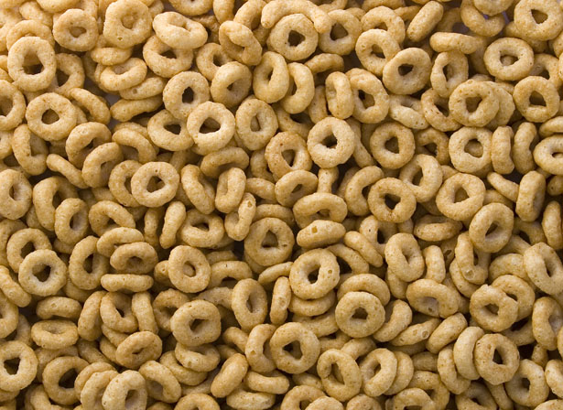

Cereal Drive

Every week, dedicated teachers and volunteers in #NUMBER breakfast programs across the NAME Regional Centre for Education spend their mornings making sure all students have the opportunity to start their day off right with a healthy breakfast.

**Help feed Nova Scotia kids at school!**

You can help support a local school breakfast program by purchasing cereal from the list provided below.

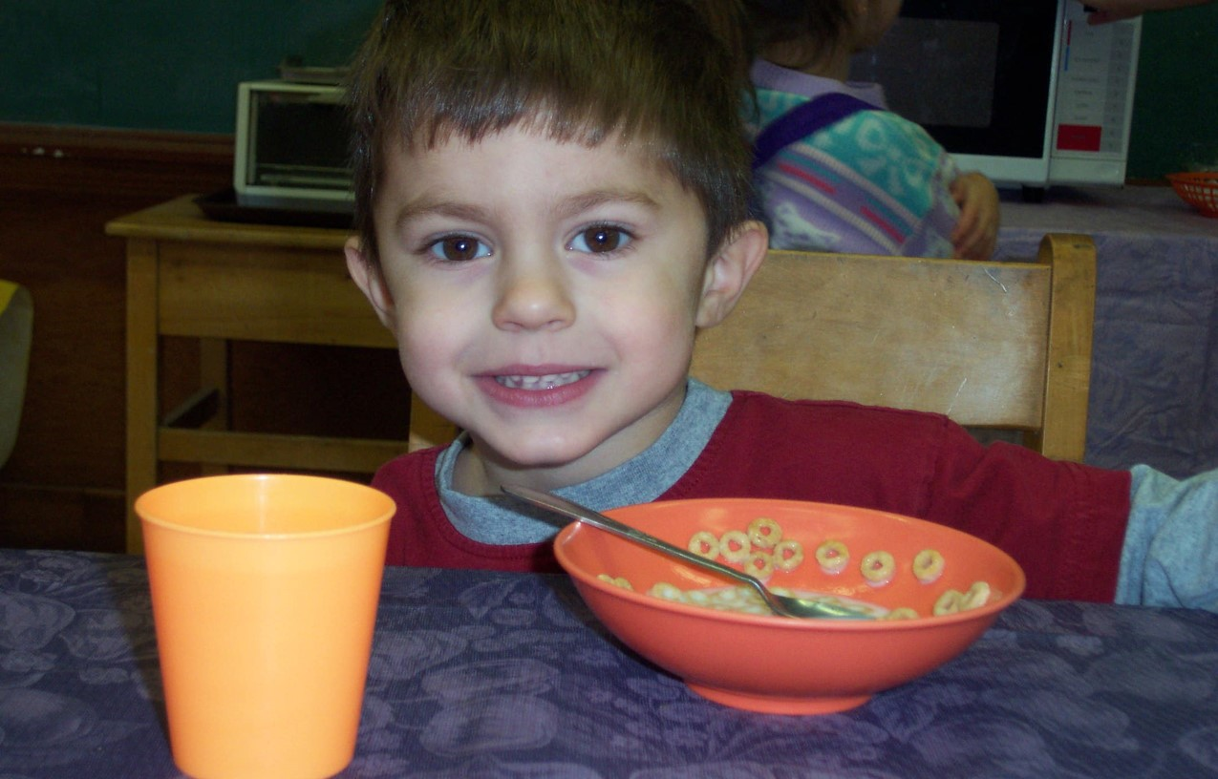

* Oat O’s, **Regular** Cheerios, Toasty-O’s
* Wheat Squares, Shreddies, Life Cereal
* Oatmeal Squares, Quaker Life Original
* Whole flake oatmeal, Bran Flakes

**No flavored cereals please**

(i.e. honey nut, vanilla, frosted)

Cereals can be dropped off at:

Dates:

Campaign Contact:

Cereal is a staple item for all programs, whether it’s a sit down meal or grab and go.

By donating these cereals, you are saving schools time and money

and providing a healthy breakfast option for children at that school.

The above cereals meet the criteria for the Food and Nutrition Policy for NS Public Schools.